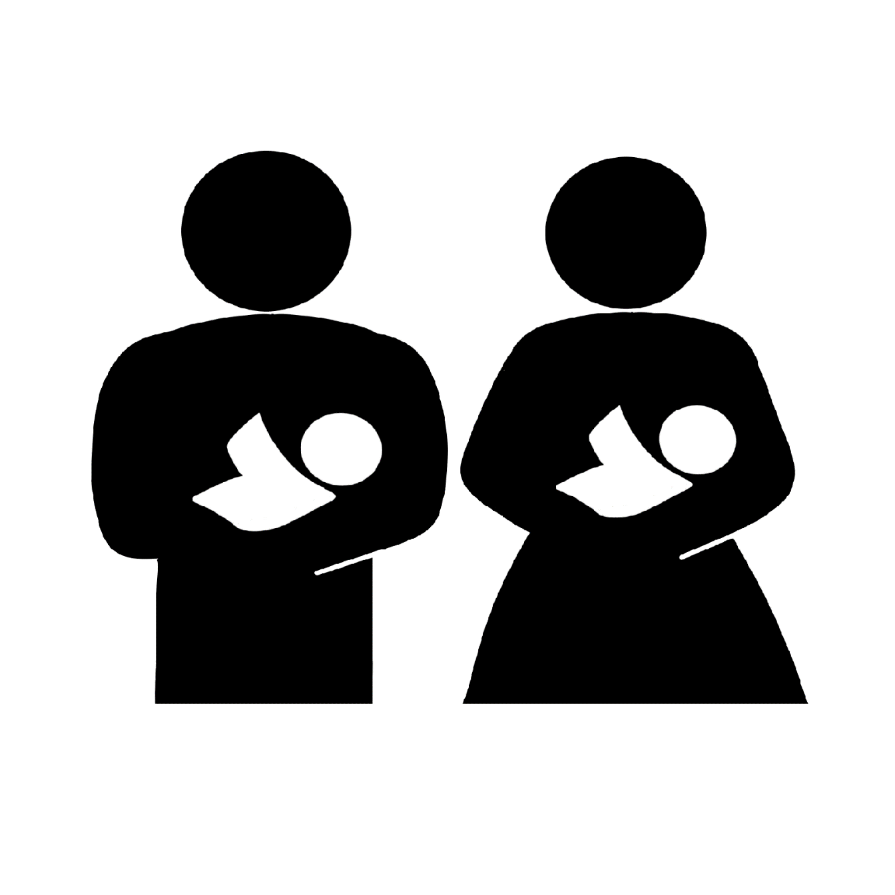
授乳室(男女共用)
ミルクを あげる ところ
(おとこ・おんな)
Nursing Room(Male/Female)

